SysTec is looking to enter the global smart thermostat market. We have begun developing a prototype using the Texas Instrument Simplelink wireless microcontroller development kit to do so. To enter the market and provide our customers with a competitive edge, we will analyze the hardware architecture of our prototype TI board and those from comparable manufacturers such as Microchip and NXP (formerly Freescale). Each of the three manufacturers provides various products that may suit our needs. We must narrow the field by looking at the technical and business requirements that must be satisfied to produce an effective and reliable smart thermostat for our customers.

**Business and Technical requirements**

To enter the Internet of Things (IoT) market with our smart thermostat design, we must ensure that the user can first adjust and engage with their heating, ventilation, and air conditioning (HVAC) system and be able to connect, read, and adjust their HVAC system via the cloud. The thermostat will need a means to positively and negatively adjust the set temperature that the user desires, engage with the HVAC to activate the heat when the set temperature is higher than the device's temperature reading and transmit that information to the cloud.

The application needs to accomplish several tasks to ensure its function and usability. The application will use a task scheduler to ensure each task is performed in a timely and efficient manner. This task scheduler will aid the application by making sure each of the tasks is handled at an appropriate time while not interrupting its function.

The device should have a physical button, switch, or slider to adjust the user's set temperature. Additionally, interacting with the HVAC system activates or deactivates the user's heat when the ambient temperature reaches the user's set temperature. This can be employed using a General-Purpose Input / Output (GPIO) to interact with the application to inform it of a change to the set temperature and bridge the connection of the HVAC system to close or open the heating circuit.

Using the Inter-Integrated Circuit (I2C) from the device will provide the ambient temperature reading. This is a sensor installed on the microcontroller specifically for reading temperature.

Using the device's Universal Asynchronous Receiver / Transmitter (UART) will allow the information from the GPIO and I2C to be sent to the cloud through the device's onboard wireless receiver/transmitter (R/T). Additionally, suppose the user wishes to view the room’s ambient temperature from a remote location or chooses to adjust the set temperature via the cloud. In that case, this information will be sent to the application, handled by the task scheduler, and changed as necessary.

Therefore, the minimum hardware architecture must have the following peripherals: UART, I2C, and GPIO, a wireless connection to a network and interface with the cloud, and finally, it must have enough flash and Random Access Memory (RAM) to support the code.

**Texas Instruments**

SysTec acquired a Texas Instrument (TI) Simplelink wireless microcontroller development kit CC3220S to use as the prototype. This platform provides an Arm®Cortex®-M4 Core at 80 MHz with 256 KB of RAM. Peripherals include a UART to transmit and receive data, an I2C that uses a TMP006 temperature sensor to read the ambient temperature, 27 GPIO pins, and several integrated Light Emitting Diodes (LED) used in prototype testing. Additionally, the TI CC3220S employs a Wi-Fi network processor that can connect to the current wireless standards 802.11b/g/n radio modes. (Texas Instruments, 2021).

The peripherals are used with the TI microcontroller to read the ambient temperature (I2C), adjust the user’s set temperature, engage the HVAC system (GPIO), collect that information via the RAM and application, and transmit (UART) over the onboard wireless R/T.

**Microchip**

We chose to look at the Microchip PIC32MZ microcontroller for our analysis. This robust microcontroller has the minimum hardware requirements—employing a 200MHz MIP32® Core processor capable of 1 MB of Flash memory and 256KB of Static Random Access Memory (SRAM). The peripherals on this microcontroller include but are not limited to, three UART modules, two I2C and an internal temperature sensor, 37 GPIO pins, and a wireless module capable of 802.11b/g/n radio modes. (Microchip, 2023).

Given the above-listed specifications and peripherals, this microcontroller would satisfy the business and technical requirements to produce the SysTec IoT smart thermostat.

**NXP**

Among the many products offered by NXP, we chose to look further into the 88MW32X Wi-Fi microcontroller. This microcontroller houses a 200 MHz Arm®Cortex®-M4 core, 512 MB of SRAM, and 128 KB of Read-Only Memory (ROM). The device includes peripherals that will meet our requirements, such as three UART modules, two I2C modules, 35 GPIO pins, and capable of 802.11b/g/n radio modes. (NXP, 2021).

A specifications review shows that this microcontroller does not include an ambient temperature sensor. That should be considered an additional component required to meet the technical requirements.

**Final Recommendations**

Based on the above specifications and the business and technical requirements, we believe the best product to meet and exceed our needs is the Microchip PIC32MZ. This microcontroller exceeds the technical requirements with its onboard Flash Memory and SRAM. This will ensure that the software and drivers can be stored with enough room for future development and updates. The available storage and memory space consider the need to continue refining the software by providing additional services to the users and room for security integrations.

Of the products reviewed, the Microchip PIC32MZ has the most extensive set of peripherals for our software to communicate with the cloud, the user’s HVAC system, as well as provides for additional product improvements for the smart thermostat, such as the potential of a rotating bezel to replace the setpoint increase/decrease buttons and LED/LCD user display.

References

Texas Instruments. (2021, May). CC3220R, CC3220S, and CC3220SF SimpleLink™ Wi-Fi® Single-Chip Wireless MCU Solutions, <https://www.ti.com/lit/ds/symlink/cc3220s.pdf?ts=1631196092684>

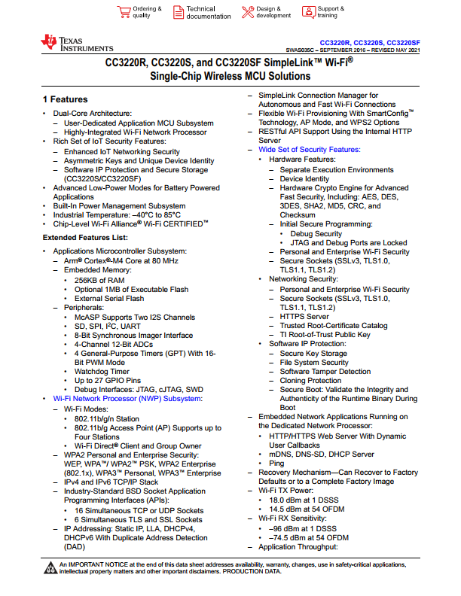

Microchip. (2023). PIC32MZ W1 and WFI32E01 Family, <https://ww1.microchip.com/downloads/aemDocuments/documents/WSG/ProductDocuments/DataSheets/PIC32MZ-W1-and-WFI32E01-Family-Data-Sheet-DS70005425.pdf>

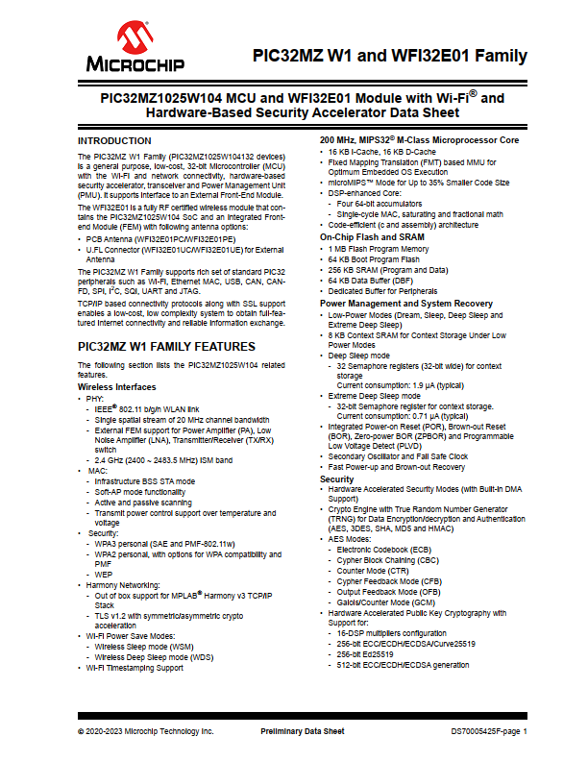

NXP. (2021). NXP® 88MW32X 802.11N WI-FI® MICROCONTROLLER SOC. <https://www.nxp.com/docs/en/fact-sheet/88MW32X-FACT-SHEET.pdf>

